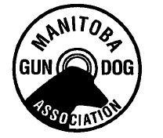

Manitoba Gun Dog Association Inc.
Annual General Meeting Agenda – November 27, 2019

- Review and Approve minutes of 2018 AGM:

- Business arising from minutes:

- Presidents Address:

- Report of the Treasurer:

- Report of Grounds Committee:

- Communication: - Survey Regarding Combining of National Events

- Proposed By Law Changes

- Report of the Nominating Committee:

- Election of Officers and Nominations from the Floor:

- Proposed By Law Changes

- New Business:

- Adjournment:

