Grounds Use
  - 2021
Preserving Working Retrievers since 1935

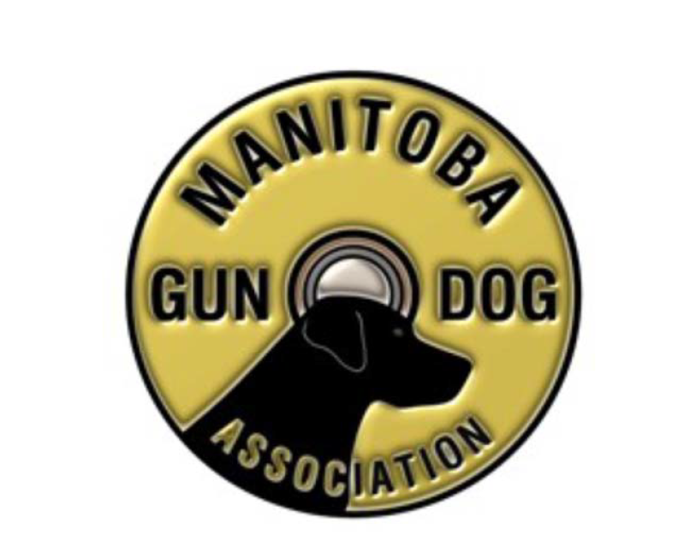

Note: Wherever "MGDA" appears throughout this document it shall be interpreted and read as "The Manitoba Gun Dog Association Inc."

Access, Liability and Rates
- Access is subject to the conditions specified in this document. Failure to comply may cause rights and privileges to be revoked.

- The MGDA Executive Committee reserves the right to preclude any / all training on specific days for grounds maintenance or MGDA sponsored events. Training is not allowed on the day preceding events.

- The MGDA will not assume or be held liable for any loss, injury or damage that may be incurred during the use of the grounds or for any loss, injury or damages to contestants, participants, workers, spectators, trainers or trainees' dogs or property of any of the above, during the course of use of the grounds.

- Clubs and / or Associations and Professional trainers must have a valid Certificate of Insurance sufficient to cover any liability for loss, injury or damage to users, dogs, or any property. The minimum acceptable amount is $5,000,000.00.

- Clubs and / or Associations are fully responsible for the safety of the contestants, participants, event workers, spectators, etc.

- All those training on or using MGDA's facilities are expected to acquaint themselves with all MGDA rules, policies and procedures and to comply with them. The following documents are posted on the MGDA website (www.manitobagundog.com) and on the Clubhouse bulletin board.
- Clubhouse Use,
- Equipment Use,
- Firearms Use,
- Rules and
- Security.
- CKC "Rules of Conduct" also apply to everyone on the grounds.
- Failure to comply may cause rights and privileges to be revoked.

- All fees will be in the form of a cash donation to the MGDA equivalent to the rates and fees noted below.

- Use of MGDA equipment must be approved by the Executive Committee, submit request to the MGDA Secretary
- Any equipment used (boats, blinds, etc.) must be put away or left in a secure manner;
- Blasters or firearms are not to be used except as specified in the Manitoba Gun Dog Association Inc. Firearms Use policy.

Use of grounds by Clubs / Associations other than The Manitoba Gun Dog Association

Prior to February 28th of each year, the Executive Committee will determine the availability of the MGDA's grounds for use by clubs and associations, duly registered for the purpose of holding Field Trials, Hunt Tests, Working Certificate Tests, matches, competitions, displays or other events that promote social interaction between members and their guests. Up to a maximum of 3 weekends (total 6 days) in the calendar year may be available for use.

The Executive Committee shall consider whether the event is in keeping with the objectives of the MGDA, whether it will conflict with other previously approved events and ensure that the club / association holding the event has met or will be able to meet the terms and conditions of use.

If the Executive Committee determines that the MGDA's grounds will be made available for use, the Committee shall:
  - Ensure that the selected dates are at least 7 days prior to a licensed Field Trial, Hunt Test or Working Certificate Test scheduled to be held in Manitoba;
  - Set the annual grounds usage donation fee;
  - Determine other conditions of use as it deems necessary.

The Executive Committee shall only consider those applications that are submitted in writing (email is acceptable) at least 45 days prior to the date the event is to be held and accompanied by an acceptable Certificate of Insurance and payment of the grounds usage donation.

Use of grounds by Trainers

Professional Trainers are individuals who receive payment for the training or handling of another person's Field Trial, Hunt Test, Working Certificate or hunting dog. Note: This excludes current MGDA life members.

Application for grounds use accompanied by a copy of an acceptable Insurance Certificate, must be submitted to the MGDA Secretary for Executive Committee approval.

Rates for Professional Trainers:
    - $600.00 per month for a 4-day week, Monday through Thursday.
    - $200.00 per week for a 4-day week, Monday through Thursday.
    - $75.00 per day, Monday through Thursday.
    - Training must be completed by 4:00 PM each day.
    - Does not include use of MGDA's equipment.
    - Restricted to a maximum of 2 professional trainers concurrently.

Amateur Trainers are individuals who have not received payment for the training or handling of another person's Field Trial, Hunt Test, Working Certificate or hunting dog or who have been reinstated as an amateur by the CKC in accordance with the Retriever Field Trial Rules & Regulations.

Amateur Trainer (Member/Non-member):
    - Active, Active Spousal and Life members may train on the grounds free of charge.
    - Junior members
    - Junior, Honorary and Spousal members may train on the grounds free of charge provided they train with or are supervised by an Active, Active Spousal or Life member.
    - Non-members and Associate members who reside over 150kms from Winnipeg may train on the grounds free of charge provided they train with or are supervised by an Active, Active Spousal or Life member.

Handlers (Professional or Amateur):
    - May train on the MGDA grounds free of charge the week prior to and / or the week following an MGDA event in which they are entered.
    - Junior members and handlers who are not eighteen (18) years of age must train with or be supervised by a person who is at least eighteen (18) years old.
    - Does not include use of MGDA equipment.
    - Training must be completed by 4:00 PM each day.

Grounds Etiquette
- Respect for other trainers/members is a must:
- Do not set up near or in such a way that your presence or training set-up will interfere with other trainers.
- Maintain control of your dogs at all times. Do not allow them to interfere with other training tests or other trainers' dogs.
- Do not enter a training area if someone is there, until signaled to do so.
- Do not block the entry to training areas. Park so that other vehicles can pass
- Area use precedence will normally follow a first-come, first-served basis. However members are requested to be considerate of those members whose employment may restrict the times available for their use of club grounds.
- Do not plan or show up to train on the club grounds on those days when work parties are scheduled. To train in front of members who have forfeited their opportunity to train is an exercise conducted in extremely poor taste.
- The humane treatment of dogs is absolutely essential. Educated and humane pressure for training purposes is allowed. Abusive treatment of dogs in any form will not be tolerated. Uneducated and excessive pressure is considered abusive.
- Please "air" dogs in designated area which is north of the North East Pond or "off-premises".
- Spectators at events should dress in dark or camouflage colours.

- Please respect our neighbours:
  - Do no trespass,
  - Do not block roads,
  - Do not litter.

ADDITIONAL EXPECTATIONS FOR ALL GROUNDS USERS

Sportsmanship
Good sportsmanship is viewed as a commitment to fair play, ethical behavior and integrity. In perception and practice, sportsmanship is defined as those qualities which are characterized by generosity and genuine concern for others:
- Play fair, take loss or defeat without complaint, or victory without gloating
- Treat others as you wish to be treated
- Respect others and one's self
- Impose self-control, be courteous, and gracefully accept results of one's actions
- Display ethical behavior by being good (character) and doing right (action)
- Be a good citizen.

Sportsmanship Traits
- Courage is having the determination to do the right thing even when others don't; the strength to exhibit fairness, to be courteous, to gracefully accept the result of the contest, to attempt difficult things that are worthwhile.
- Good Judgment is choosing worthy goals; setting priorities in accordance with the rules; leading others to follow these rules.
- Integrity is having the inner strength to be fair and courteous during events, to play according to the rules, acting positively and honorably to all.
- Kindness is being considerate, courteous, and generous in spirit, showing care, compassion and friendship in victory or defeat; treating others as you would like to be treated.
- Perseverance is being persistent in pursuit of worthy objectives in spite of opposition, difficulty, injuries, handicaps or discouragement, and exhibiting patience and the fortitude to try again when confronted with mistakes or failures.
- Respect is showing high regard for judges, workers and other participants.
- Responsibility is being dependable in carrying out obligations and duties, showing reliability and consistency in words and conduct, and being accountable for your actions.
- Self-discipline is demonstrating hard work and commitment to purpose, regulating yourself for improvement and refraining from inappropriate behaviors, maintaining self-control at all times, and doing your best in all situations.

Following are some general rules to be a good sport, and a "Code of Sportsmanship" adapted from the CKC Field Trial Rules and Regulations.

Good Sportsmanship Rules
- The "Golden Rule" Do unto others as you would have others do unto you; show respect for them if you expect it yourself.
- Have an understanding and an appreciation of the rules; the spirit of good sportsmanship depends on conforming to the intent of the rule and not looking for a loop hole.
- Enjoy yourself and encourage enjoyment for others; we participate in retriever events for recreation so let's make it that.
- Take responsibility for your actions; don't blame others for your mistakes or find excuses for poor behavior.
- Recognize and appreciate good performances, by the other participants; Applause for the other participants' good performances demonstrates generosity and courtesy shows a true awareness of the dogs' ability.
- Exhibit respect for the judges. Judges are impartial arbitrators who perform to the best of their ability to make sure the event is fair and within the rules. Mistakes made by all those involved are part of retriever events and must be accepted.
- Expect proper behavior from all participants. If you allow a participant to cheat, to kick, strike or otherwise roughly manhandle a dog, to abuse or harass a judge, official or any other person present in any capacity at an event, you are condoning that behavior.

Code of Sportsmanship
- Sportsmen always consider as paramount the welfare of the dogs.
- Sportsmen commit themselves to values of fair play, honesty, courtesy, and vigorous competition, as well as winning and losing with grace.
- Sportsmen refuse to compromise their commitment and obligation to the sport by injecting personal advantage or consideration into their decisions or behavior.
- The sportsman judge judges only on the merits of the dogs and considers no other factors.
- The sportsman judge treats all handlers, trial officials or any other person present in any capacity at the event with courtesy, respect, dignity and impartiality
- The sportsman refuses to compromise the impartiality of a judge.
- The sportsman respects the bylaws, rules, regulations and policies governing the sport and conforms to the spirit as well as the letter of the rules.
- Sportsmen find that vigorous competition and civility are not inconsistent and are able to appreciate the merit of their competition and the effort of competitors.
- Sportsmen welcome, encourage and support newcomers to the sport.
- Sportsmen respect the history, traditions and integrity of the sport
- Sportsmen refuse to embarrass the sport or themselves while taking part in the sport.
- Sportsmen are concerned with the behaviors of all involved in the sport.
- Sportsmen take responsibility for their actions.
- Sportsmen exhibit respect for the officials

